Marble Game – Assignment

Robot Computer Vision by Professor Jacky Baltes

Report By Kevin & Philip

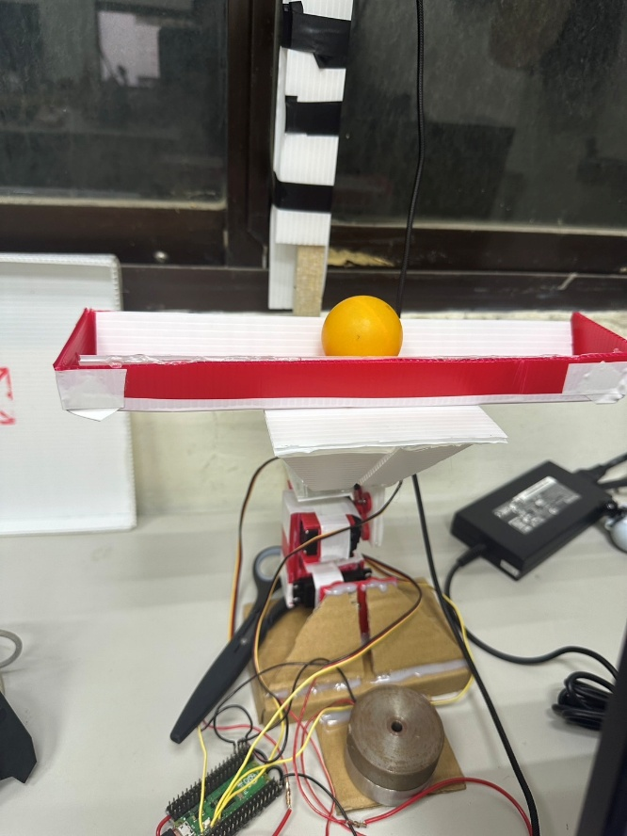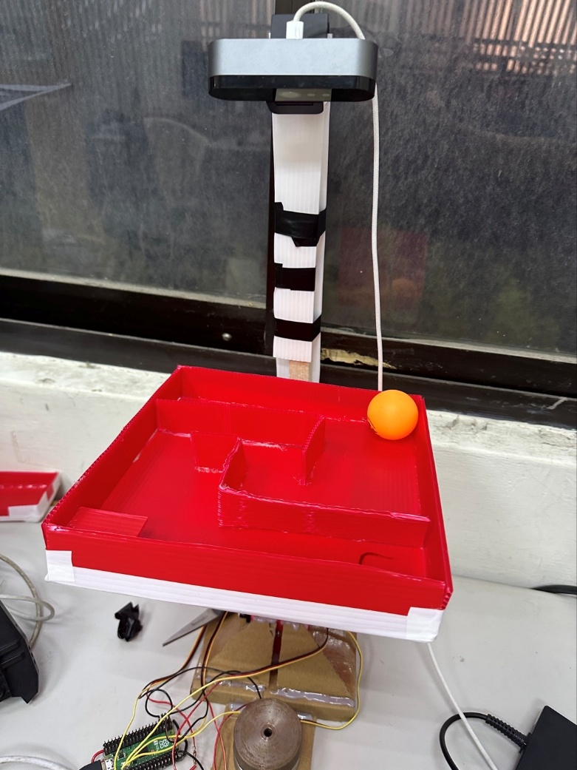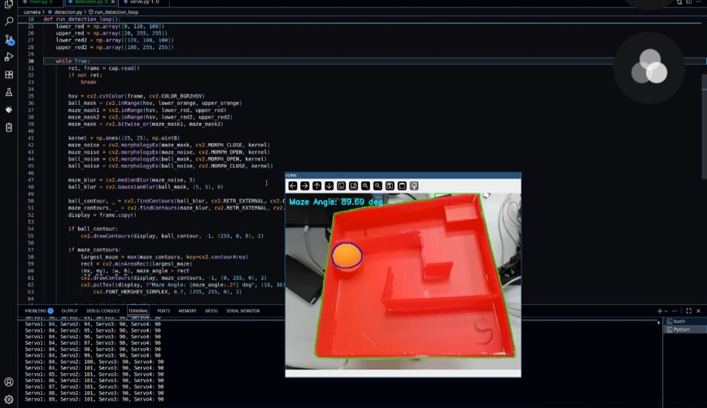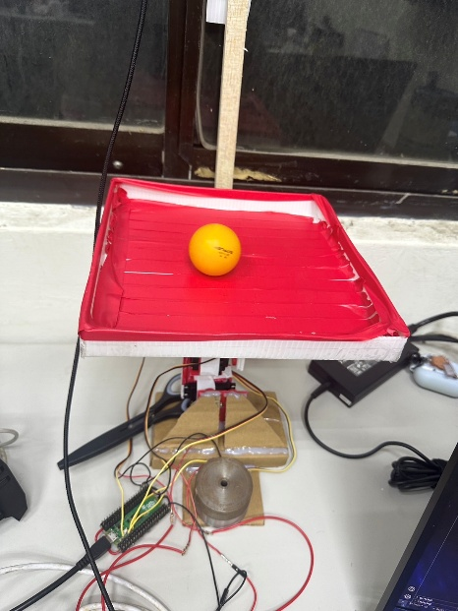

The goal of this assignment is to demonstrate our ability to control the position and orientation of the hip of your leg. we will demonstrate the control using a small fun marble game.

During this period of working together with our team were really a good experience, we would say that we studied a lot through this project, from less known to the well of understanding.

1. **Tools**

there is two main point that need to explain is the Hardware and software, and for the **Hardware**:

* Four HITEC HS-311 servo motor,
* Logitech camera,
* maze from plastic board,
* foot link created with plastic board,
* base link created with cardboard box
* PI Pico 2 Microcontroller
* Power Bank

We built everything based on our knowledge and references from google images

**Software:**

This is the library to connect our Vs Code to Pi Pico

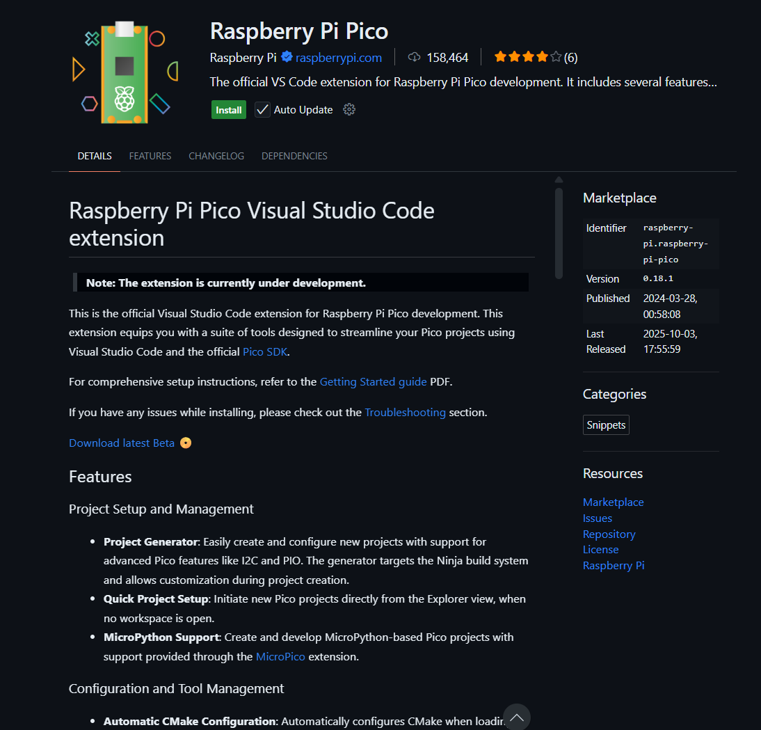

**servo.py**

we simply import the library like machine for setup the pin that later we will send data to our pi pico pin and sys for extract the received data before sent to the pin.

We put every motor angle to 90 degree for the fresh start every time we run pi pico so that we ensure every motor should in the home position.

set_servo_angle is used to set the servo angle and we put the minimum and maximum limit for the motor to move because we afraid that the motor will exceed the limit or could easily damaged. While true Is the loop to execute the received data.

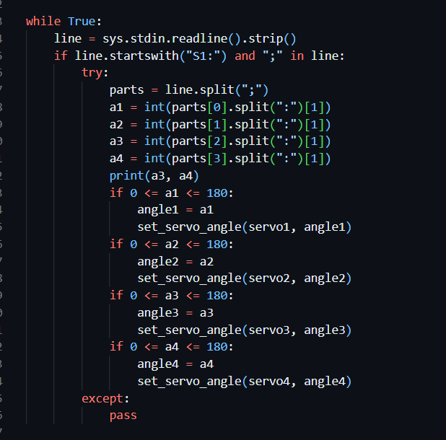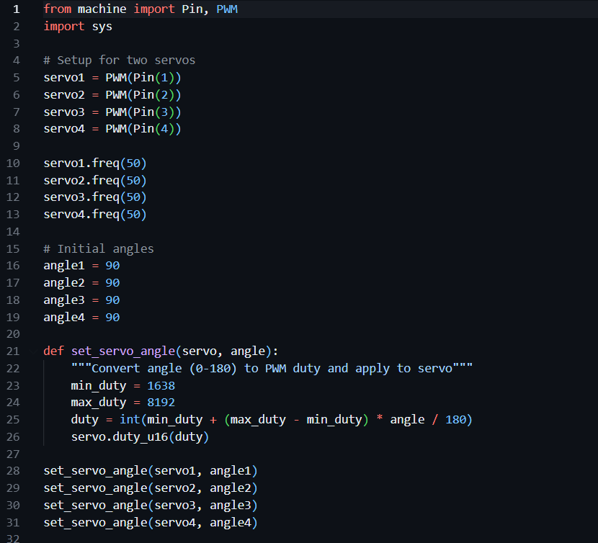

**detection.py**

is the python file to detect everything we need via camera and manipulate the received data for **PID** calculation, it uses two main powerful tools called **opencv** for camera manipulation and numpy for data manipulation.

With opencv we be able to detect the height/width of the maze, so that we could calculate the center point of the maze, as well as to calculate the angle of the maze, detect the ball for drawing a circle and receive the ball location, everything has done by **Contour with HSV Color Detection.**

For calculating the PID **Controller** is not really hard if we already have all the information needed, the challenging part is how do we measure the following term with our robot leg

KP: Proportional term: this controls how quickly to turn the steering when the heading is not at the set value.

KI: this can be used to limit the speed of the steering response.

KD: this can be used to limit the speed of the steering response.

In this part, everytime if the value didn’t fit then I need to change it, and test it again until it exactly fit with our robot leg.



1. **Result**

We have the result in video format which shows everything we have done so far, we have recorded total three video per challenge and the video should be uploaded in the same directory with this report and every source included the code also will be upload.

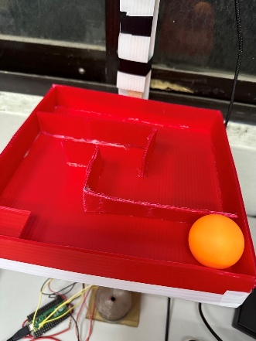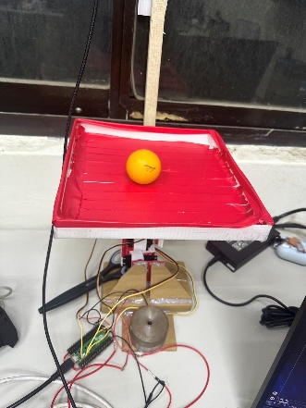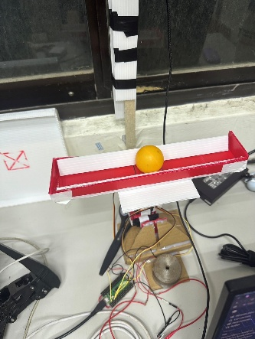

But fortunately, in the end we can control all the servo with arrow keys and alphabet, also detected the maze, ball for angle and location and we are able to utilized PID so that the ball will be always in the middle as the target position automatically controlled by the PID via servo.